Bendix G-15
The Bendix G-15 computer used a magnetic drum for storage, and because of rotational latency, it wasn’t efficient to have each instruction follow one another in memory. Therefore, Harry Huskey, the machine’s designer, required each instruction to include the address of the next one, and then the instructions could be arranged optimally on the drum.
The G-15 was fast for its time. Double-length arithmetic registers simplified programming double-precision operations. A single instruction could operate on one word or a group of words. Several G-15s could compute simultaneously and communicate with each other. A compiled language called ALGO was available.
Bendix sold over 400 G-15s before Control Data took over its computer business.
Sources: Paul E. Ceruzzi. A History of Modern Computing. Cambridge, MA: MIT Press, 1998. pp. 42-43
Developed at: Wayne State University, Detroit Memory technology: magnetic drum storage
First introduced: 1956 Memory size: 2,160 29-bit words
CPU technology: vacuum tube Memory access speed: 14.5 msec average (0.069 MHz)
http://members.iinet.net.au/~dgreen/
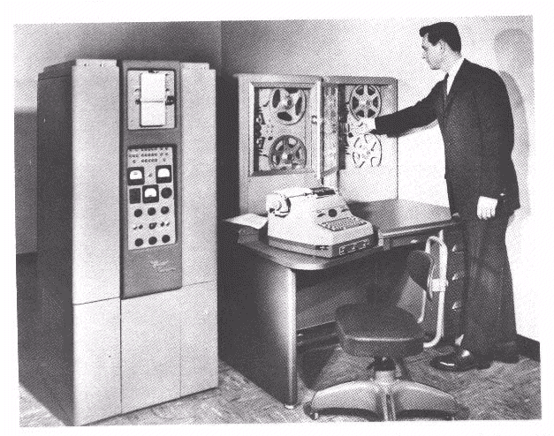
http://members.iinet.net.au/~dgreen/pics2.html

http://asuwlink.uwyo.edu/~jimkirk/g15.html

